**IOT Watson Platform**

**Team ID:** PNT2022TMID48820

Step1: Log in your registered id

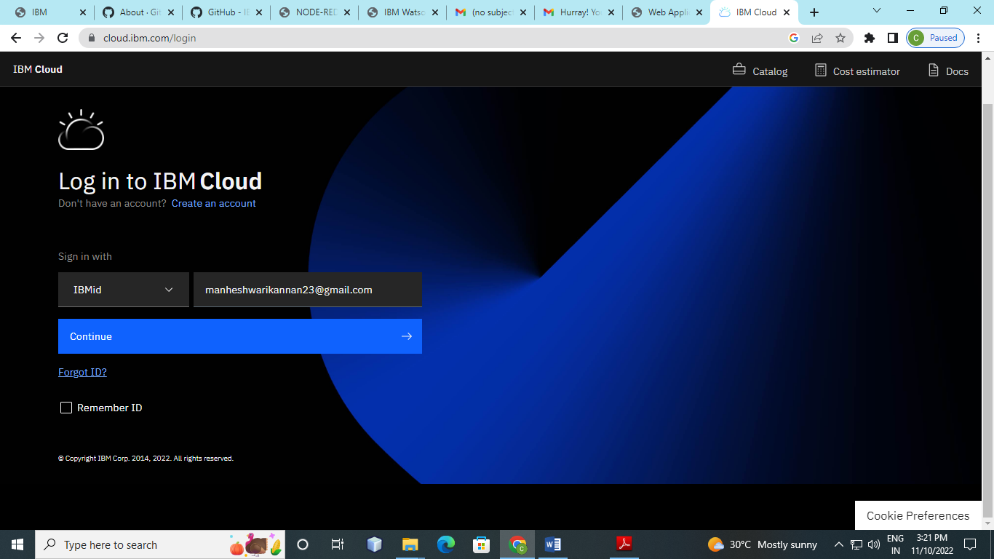

Step 2: Dash Board View

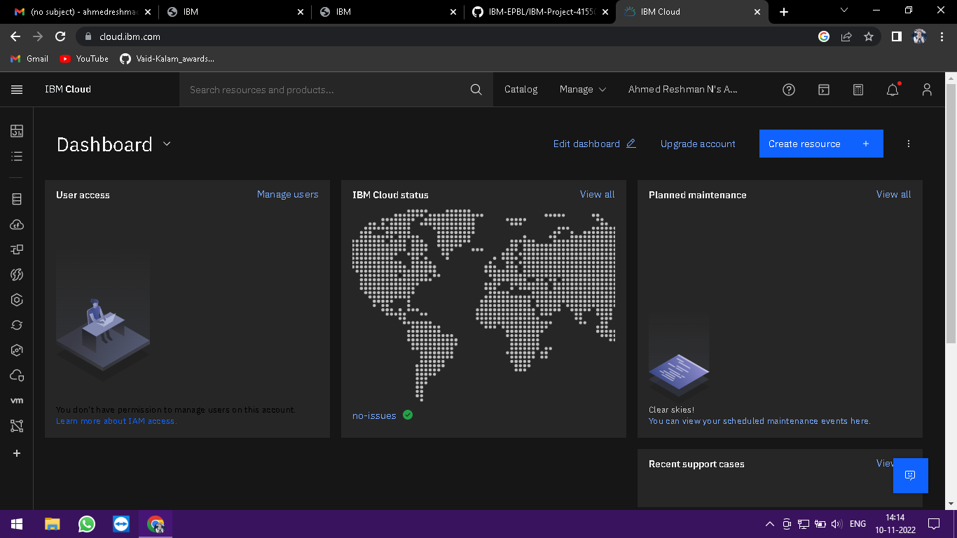

Step 3: Click create and the launch tab get open, then click launch 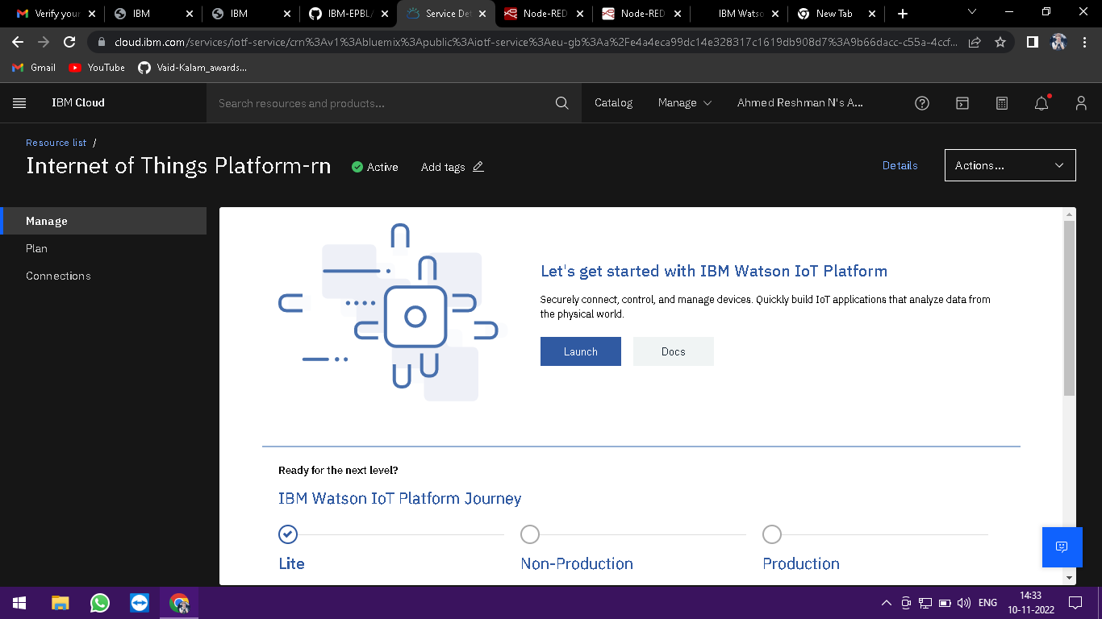

Step 4: It Redirect you to IBM WATSON platform where you need to click sign in

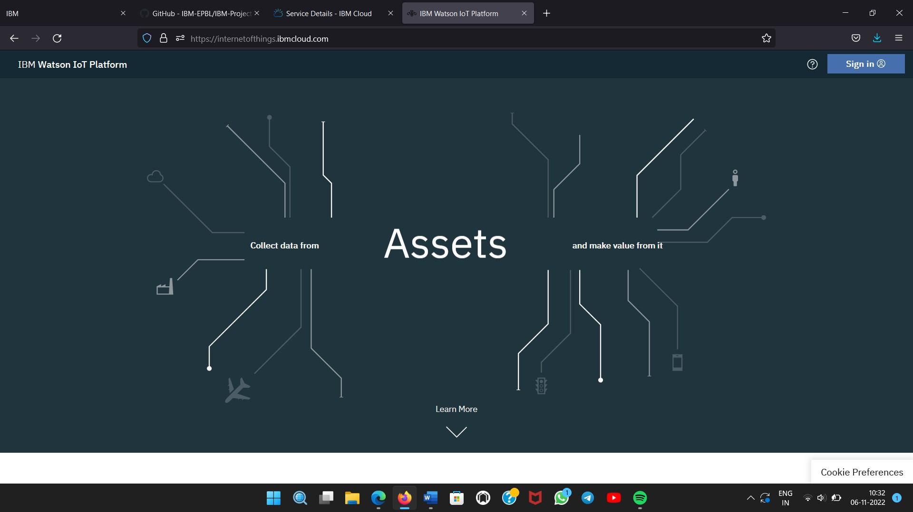

Step 5: You need to Log in IBM ID 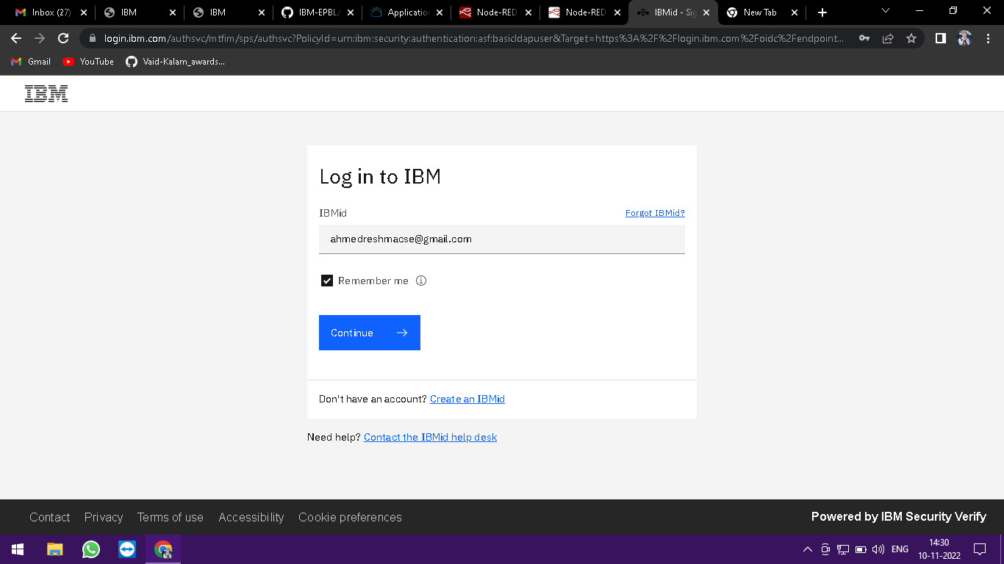

Step 6: Where you find this tab which is used to add Device Id, Status, Device Type

M